# **Catalytic Reactor Case Study Report**

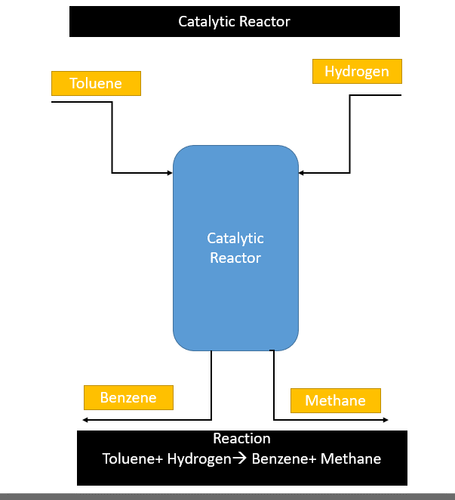

The following reaction takes place inside the above bio-reactor:

$$Toluene+Hydrogen→Benzene+Methane$$

The Experimental Data of the above bio-reactor was provided which consists of the following columns:

1. Partial Pressure of Hydrogen (PH2) (mm Hg)
2. Partial Pressure of Toluene (PT) (mm Hg)
3. Partial Pressure of Benzene (PB) (mm Hg)
4. Reaction rate (RT)

Using the given dataset based on the experimental results, we need to find a model which must be able to ***predict the*** ***Reaction rate*** for a given set of input *{PH2, PT, PB}*.

Hence, the target variable is *RT* and the input variables are *{PH2, PT, PB}* for training of the model.

## Approach

Before we start modelling, we need to be sure that the data is properly cleaned, i.e., there are no missing or null values, and there are no outliers in the given dataset. Since the dataset is not so big and have only 150 rows, the absence of any missing values is easily identified. We can also cross check for any null values with the help of “COUNT()” function, which will give the count of all the numeric values in a particular column. If the value of count function is equal to the number of rows, then null values are not present. In order to identify outliers, I made use of Box and Whiskers Plot to identify the outliers. On plotting Box and Whiskers Plot for each column, there was no outliers for the input variables, but outliers were present for the output/target variable. I replaced the outlier value with the mean of the target values to avoid data loss and my model is not affected by them.

Now, since we have checked the data for any outliers and treated the outliers and finally obtained the cleaned data, we can now proceed with modelling.

## Code and Explanation

function performance = performanceFn(mse,R)

performance = (1 - R*R) + mse;

end

function [Parr, R2, ape, mse, netarr, trarr] = determineHiddenLayerSize(x, y, maxSize)

Parr = zeros(maxSize, 1, "double");

R2 = zeros(maxSize, 1, "double");

mse = zeros(maxSize, 1, "double");

ape = zeros(maxSize, 1, "double");

netarr = cell(maxSize, 1);

trarr = cell(maxSize, 1);

for i = 1:maxSize

% Defining the architecture of ANN

hiddenLayerSize = i;

net = fitnet(hiddenLayerSize, 'trainlm');

net.divideFcn = 'dividerand';

net.divideParam.trainRatio = 0.70;

net.divideParam.testRatio = 0.15;

net.divideParam.valRatio = 0.15;

net.trainParam.showWindow = 0;

[net, tr] = train(net, x, y); % training the model

netarr{i} = net;

trarr{i} = tr;

yPredicted = net(x);

[R, ~, ~] = regression(y, yPredicted, 'one');

R2(i) = R*R;

mse(i) = mean((yPredicted-y).^2);

ape(i) = mean((abs(yPredicted-y)/y)*100);

Parr(i) = performanceFn(mse(i), R);

end

end

[x, target] = catalyticReactor();

maxSize = input("Enter maxSize:");

resMinP = 1e7;

resMinPidx = -1;

[Parr, R2, ape, mse, netarr, trarr] = determineHiddenLayerSize(x, target, maxSize);

for i = 1:maxSize

if(resMinP > Parr(i))

resMinP = Parr(i);

resMinPidx = i;

end

end

disp("Performance value:"); disp(resMinP);

disp("R2 value:"); disp(R2(resMinPidx));

disp("MSE value:"); disp(mse(resMinPidx));

disp("APE value:"); disp(ape(resMinPidx));

network = netarr{resMinPidx};

y = network(x);

figure, plotperform(trarr{resMinPidx});

figure, plottrainstate(trarr{resMinPidx});

figure, plotregression(target, y);

genFunction(network,'myNeuralNetworkFunction');

y = myNeuralNetworkFunction(x);

disp(y);

save('catalyticReactor');

|  |  |
| --- | --- |
| performanceFn(mse,R) | Finds the performance of the model based on the MSE (Mean Squared Error) and R value, according to the equation: (1 – R2) + MSE.  Lower the value, better is the model.  Argument Details:  mse = MSE (Mean Squared Error)  R = Pearson’s correlation coefficient (R2 = coefficient of determination) |
| determineHiddenLayerSize(x, y, maxSize) | Trains the model for different layer sizes varying from 1 to maxSize. It iterates through each an every value from 1 and trains the model based on current value or the current layer size. Now, once the model is trained in the current iteration, we find the performance value that model.  In this way, when the iteration is completed, we have the following arrays:   1. Performance array (Parr) 2. Average Performance error Array (ape) 3. Mean Squared Error Array (mse) 4. Coefficient of Determination Array (R2) 5. Model Array (netarr) |

In the main code, we make use of the above defined functions and their return values to find the most suitable and optimum model. We just iterate through the arrays returned and the index value having the lowest performance score is the best model. We just maintain a variable ‘network’ which stores the best model after the iteration completes. Finally, this ‘network’ is used to get the plots and y value.

## Results

|  |  |
| --- | --- |
| Name | Value |
| Mean Squared Error (MSE) | 1.838382377 |
| RMSE | 1.355869602 |
| R2 | 1 |
| Average Percentage Error (APE) | 1.031981464 |
| Nodes or Layer Size | 12 |

From the above provided values and the graph, the developed model is very accurate, but it shows some amount of error in some cases, but the contribution of error is very less.

***Hence, the model can be used to predict the Reaction Rate of production from the partial pressure of Hydrogen, Toluene, and Benzene in real life scenario.***